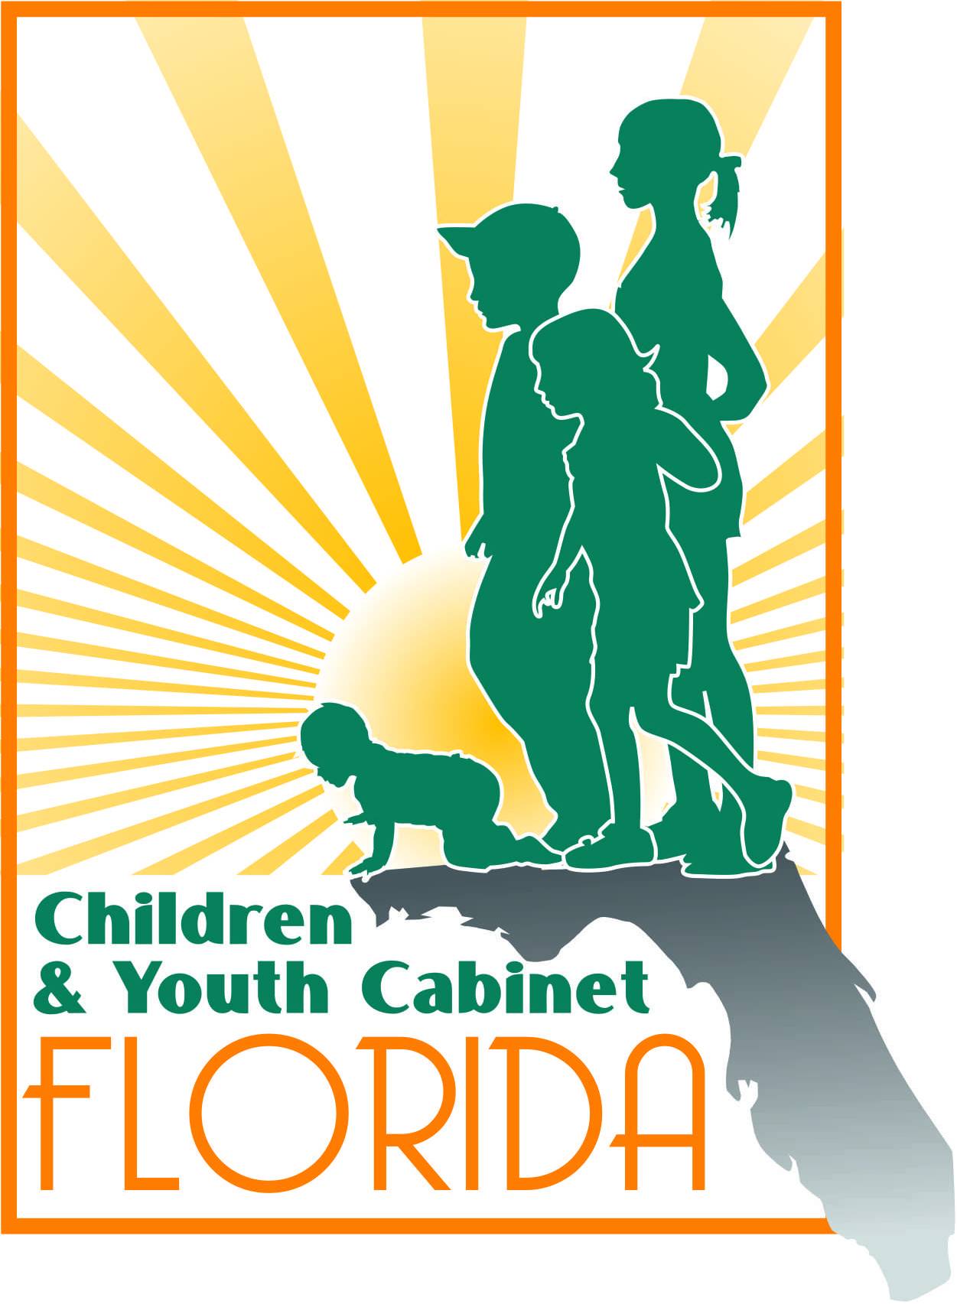
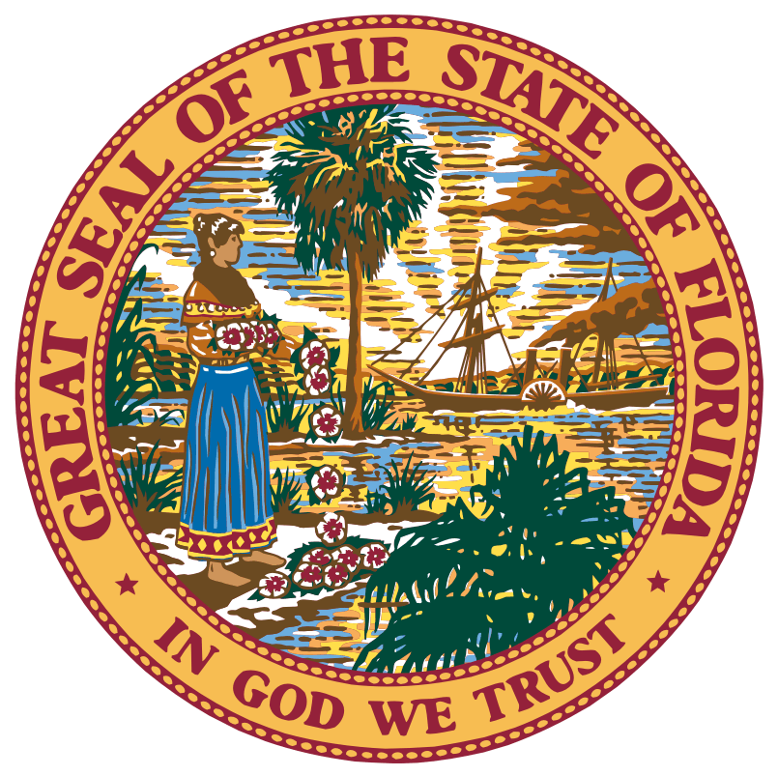
Florida Children and Youth Cabinet Meeting
November 13, 2017
1:30 p.m. – 5:00 p.m. EST
Judicial Meeting Room
Florida Supreme Court
500 South Duval Street, Tallahassee, FL 32399

Meeting Summary

Note: The following is a summary of the highlights of the proceedings and is not intended to be construed as a transcript. To obtain meeting materials, please visit www.flgov.com/childrens-cabinet.

Attendance Summary

FCYC members in attendance:

- Chair Wansley Walters
- Director Alan Abramowitz
- Secretary Mike Carroll
- Secretary Christy Daly
- Director Zackary Gibson
- Representative Gayle Harrell
- Judge Sandy Karlan (Ret.)
- Director Rodney MacKinnon
- Director Barbara Palmer
- Dr. Celeste Philp
- Vice Chancellor Jacob Oliva
- Diana Ragbeer
- Steve Uhlfelder
- Victoria Vangalis Zepp
- Tanya Wilkins
- Superintendent Sam Himmel

Member Representatives and Guests in Attendance:
- Dr. Norin Dollard, Florida KIDS COUNT
- Meghan Murray
- Honorable Amanda Wall

Staff in Attendance:
- Lindsey Perkins Zander

Member Representatives and Guests on conference call:
- Sue Gallagher, the Children’s Services Council of Broward County
- H. Kay Howard, Third Sector Capital Partners
- Rebecca Bouquio, Agency for Persons with Disabilities

Proceedings
Call to Order and Welcome
Chair Wansley Walters called the Florida Children and Youth Cabinet (Cabinet) meeting to order and welcomed Cabinet members.

The roll was called by Lindsey Zander and quorum was confirmed.

Technology Workgroup Update: Empowering Families Initiative Presentation
Victoria Zepp, Chair of the Technology Workgroup Committee, provided an overview of the Technology Workgroup’s progress in data integration across departments. Sue Gallagher of the Children’s Services Council of Broward County gave an update on the Local Integrated Data System Pilot in Broward County. H. Kay Howard of Third Sector Capital Partners informed the Cabinet that the focus of the work is to apply data sharing to measure interagency and multi-generational outcomes. The workgroup will be focusing on unique identifiers to integrate the system with other data systems. They aim to build out the current data sharing piece by the end of spring and get through testing, in order to have a functioning data sharing system by September 2018. Representative Gayle Harrell commented that the Agency for Health Care Administration has submitted a budget request for a Medicaid IT system that utilizes a unique identifier. She requested that the Technology Workgroup maintain conversation with AHCA and other agencies so that there are accessible interfaces across systems.

Action Item #1: Technology Workgroup Chair Victoria Zepp will share a list of each agency’s technology workgroup liaison to each agency head.

Florida Navigator Presentation
Agency for Persons with Disabilities (APD) Director Barbara Palmer introduced the Florida Navigator, a web-based tool designed to assist users in researching information on state government disability programs and services. Meghan Murray led the presentation, informing the Cabinet that the purpose of the Florida Navigator is to better streamline the search for state services with consolidated information in one place. The Floriad Navigator (flnavigator.org) is a distinct from the Resource Directory (http://resourcedirectory.apd.myflorida.com/resourcedirectory/), which connects constituents to local community resources, because it connects constituents to state government. Both services can be found on the APD website. APD welcomed any suggestions and feedback on how to improve the resource to involve partner agency services.

Action Item #2: Meghan Murray will share her contact information to agency representatives for feedback on how to improve the Florida Navigator.

Action Item #3: Technology Workgroup Chair Victoria Zepp will have Florida Navigator demonstrated at next Technology Workgroup meeting in order to invite suggested improvements.

Policy Impact Committee Update
Policy Impact Committee Chair, Sandy Karlan, provided a brief update on the progress of the committee. Chair Karlan reminded the Cabinet of its three priorities:
- Continued focus on zero to three (0-3) (education) with an additional focus on School Readiness of children in the 3-5 age range – addressing issues such as children prepared for kindergarten;
- Children living in high poverty areas (safety, health & education); addressing children in poverty; safe and affordable housing (and neighborhoods); and
- Mental Health & Substance Abuse (safety and health); this includes teens with significant behavioral/mental health issues
Chair Karlan commented that agencies are currently working to establish systems that utilize a unique identifier, improve workforce capabilities, and support youth transitioning through different state services. However, she also lauded the agencies for their renewed focus on engaging with and learning from each other in order to support the Cabinet and Florida’s youth. The Policy Impact Committee will meet again in December.
Action Item #4: Lindsey Zander will coordinate with the Policy Impact Committee members to select the next meeting date in December.

Overview of Agency Legislative Initiatives relating to Cabinet Priorities
Department of Juvenile Justice (DJJ) Secretary Christy Daly commented that DJJ’s proposed legislation fits into the second and third Cabinet initiatives and suggested that having Cabinet support behind each agency’s proposed budget would be beneficial. Cabinet Chair Walters added that having partner agency leaders or representatives present at committee presentations would also be influential towards approving appropriations.

Agency for Persons with Disabilities (APD) Director Barbara Palmer commented that APD’s proposed legislation is working towards the third initiative. Their proposed legislation would assess individuals prior to their court appearances to clarify if they are eligible for APD or DCF services. APD is working to get grants for providers providing housing to individuals with extreme behavioral needs.

Department of Children and Families (DCF) Secretary Mike Carroll commented that DCF’s proposed policies address all three initiatives. DCF aims to augment medication-assisted treatment with ongoing, supplemental treatment and looks to restructure how the agency draws funding to better assist children.

Office of Early Learning (OEL) Director Rodney MacKinnon commented that OEL is requesting $7 million to fund increasing slots in school readiness programs.

Department of Health (DOH) Surgeon General Celeste Philip commented that DOH is working with partner agencies to share access to single, Florida Shots Registry to eliminate paper forms and duplicated entry. DOH also aims to improve prescribing practices by updating the Prescription Drug Monitoring Program to allow better functionality and authority to share information across states.

Guardian ad Litem (GAL) Executive Director Alan Abramowitz commented that GAL’s proposed legislation aims to renew financial support for the program, reimburse volunteer expenses, and improve work with incarcerated parents.

Agency for Healthcare Administration (AHCA) designee, Rebecca Bouquio, commented that the Agency does not have any legislative initiatives to share that align with the Cabinet’s three priorities.

Action Item #6: Lindsey to follow-up with Department of Education (DOE) Vice Chancellor Jacob Oliva regarding legislative initiatives.

Action Item #7: Legislative Liaisons within each department will let Lindsey Zander know when issues are coming up before legislative committees so that she can follow up with the Cabinet to provide notice to appear and offer support during committee meetings.

Early Childhood Court Video
Dr. Mimi Graham, Director for the FSU Center for Prevention & Early Intervention Policy, shared a video on baby court, which aligned with the Cabinet’s three priority areas.

MOU Interagency Agreement Update
Governor’s Office of Adoption and Child Protection Director Zack Gibson provided an update on the progress of the Memorandum of Understanding (MOU) Interagency Agreement for coordination of services and data collection. Each agency will receive the final draft of the agreement before it is distributed.

Public Comment
United Way representative, Ted Granger, commented that the baby court’s success lies in addressing the family as a whole.

Closing
The next Children and Youth Cabinet Meeting will tentatively take place on Monday, January 22nd in Tallahassee, Florida.

Adjournment
Chair Walters adjourns the Florida Children & Youth Cabinet meeting at 4:40 p.m.

